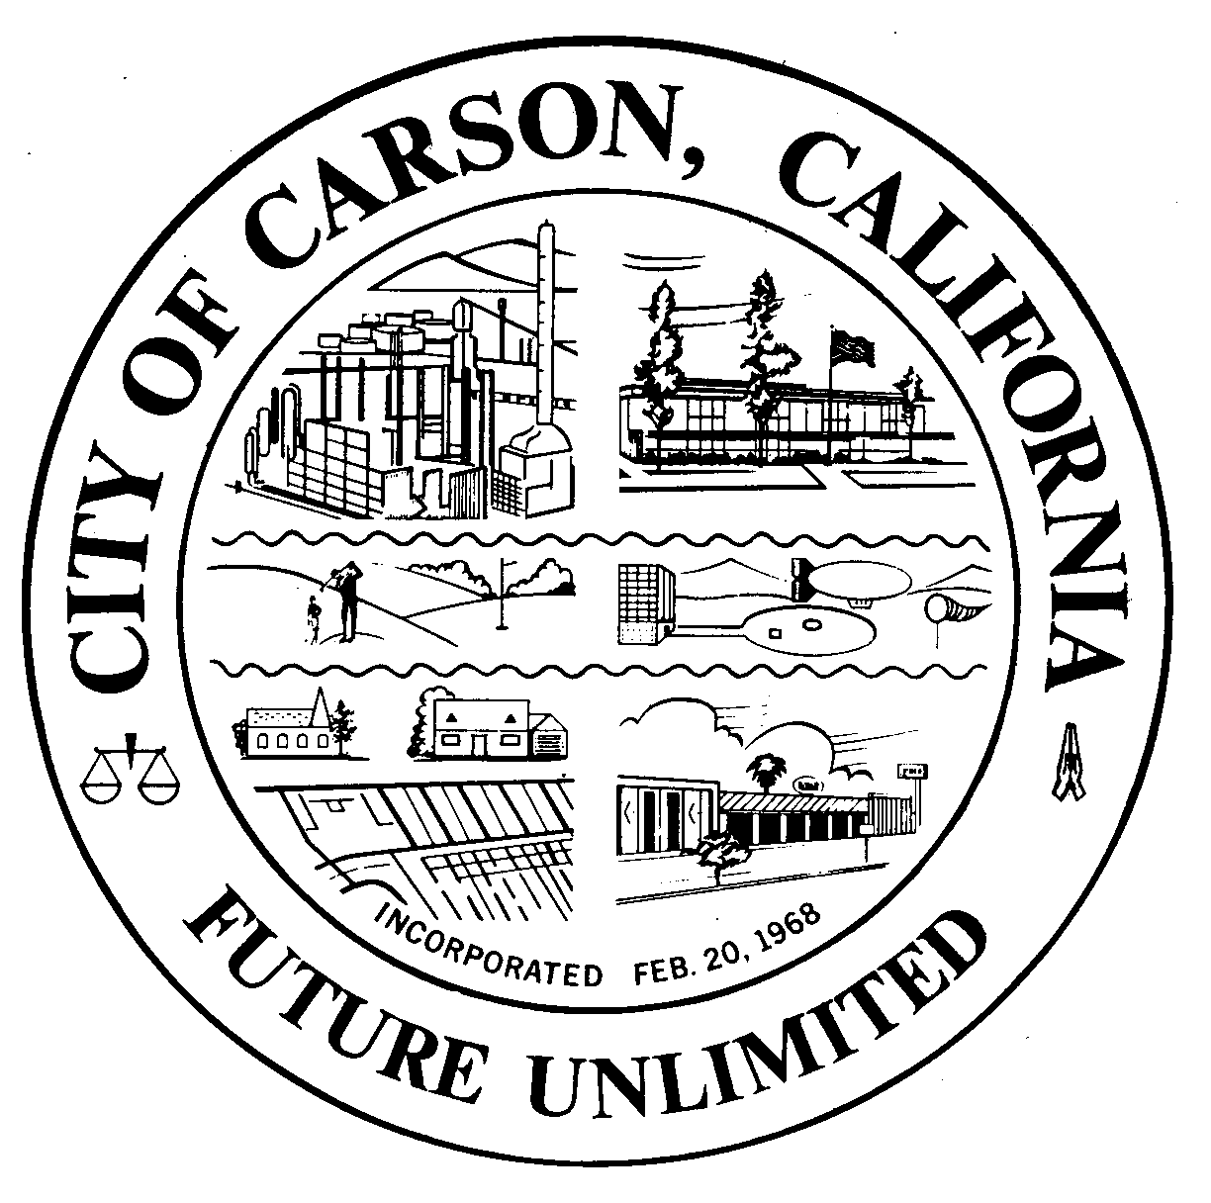
A G E N D A
CITY OF CARSON
REGULAR MEETING OF THE ENVIRONMENTAL COMMISSION
701 East Carson Street, Carson, CA 90745
EXECUTIVE CONFERENCE ROOM, 2ND FLOOR
Wednesday, February 5, 2014
6:30 p.m.

- CALL TO ORDER:

- PLEDGE OF ALLEGIANCE:

- ROLL CALL: Environmental Commissioners:
Burr, Hellerud, Hopson, Jimenez, Love, Mack, Muckey, Perry, Taylor
- AGENDA POSTING CERTIFICATION: In accordance with the Americans with
Disabilities Act of 1990, if you require a disability related modification or accommodation to attend or participate in this meeting, including auxiliary aids or services, please call the City Clerk’s office at 310-952-1720 at least 48 hours prior to the meeting. (Government Code Section 54954.2)
- AGENDA APPROVAL:
- ORAL COMMUNICATIONS: For items NOT on the agenda. Speakers are limited to three minutes.
- MINUTES APPROVAL:
  - January 6, 2014
- UNFINISHED BUSINESS
a. Enhanced Electrical Safety Policy, HERO
b. Environmental Commission Logo Discussions
- NEW BUSINESS
  - Presentation by West Basin/South Bay Environmental Services, State of California Water Crisis
  - Discuss community concerns regarding Oxy expressed to the Commissioners
- WRITTEN COMMUNICATIONS
  - None
__________________________________________________________________________
- ORAL COMMUNICATIONS
  - Audience
  - Commissioners
  - Staff
- Oxy DEIR Joint Workshop with the Planning Commission, February 11th
- Shell EIR Joint Workshop with the Planning Commission, March 12th
- HOA Presentation Project
- Participation Certificate for Ethics Training
- Certificate of Appreciation
- Cancelation or holding regular Commission meeting, March 5, 2014
- Adjournment to February 11th
__________________________________________________________________________
- ADJOURNMENT
Upcoming Meetings: Adjourn to February 11, a Special Joint Workshop with the Planning Commission on, March 5, a Special Workshop, Shell EIR CRP March 12, April 2, May 7

